AI Pipeline Architecture & Cost Optimization -> RapidSales.ai

1.Problem Overview

RapidSales.ai currently uses GPT-4o for all channels, leading to:

- High operational cost (38% of revenue)
- High latency (4.2s for voice)
- No observability (failures detected via complaints)
- No caching (repeated redundant generations)

2.Proposed AI Pipeline Architecture

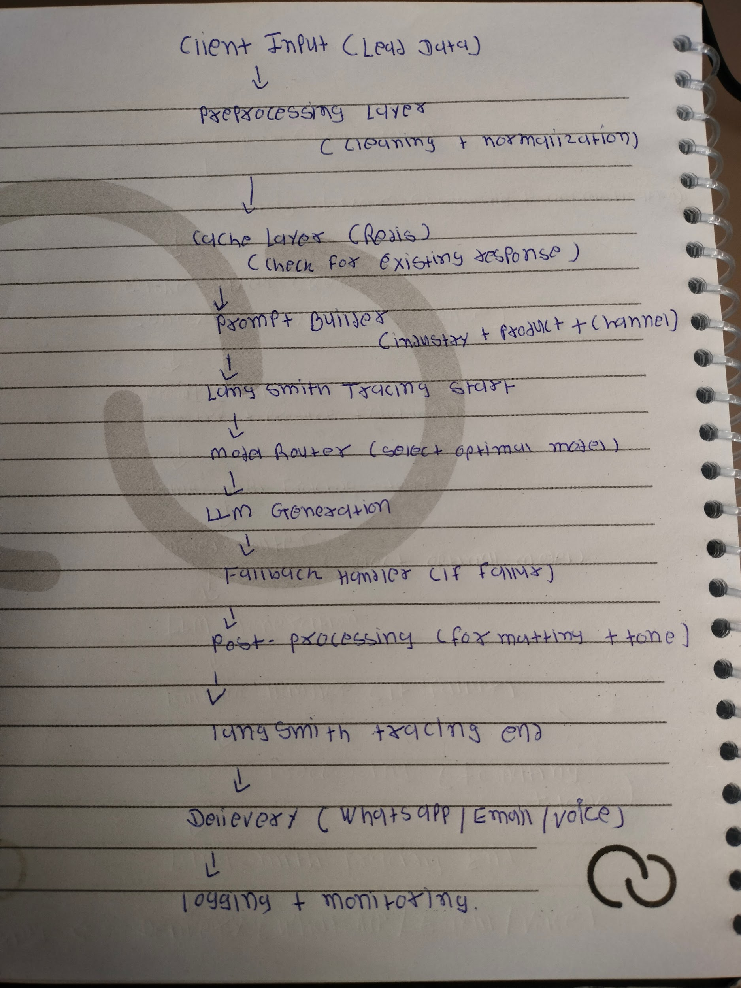

* The architecture diagram was initially designed manually for clarity and quick iteration.

3. Channel Model Used Justification

WhatsApp Llama 3 8B Low cost, fast, sufficient quality
Email GPT-4o-mini Balanced cost + quality
Voice Call GPT-4o High accuracy required

—> Key Improvements

1. Model Routing

→ Dynamic selection of cheapest suitable model per channel.

- def select_model(channel):
if channel == "whatsapp":
return "llama3-8b"
elif channel == "email":
return "gpt-4o-mini"
else:
return "gpt-4o"

2. Caching Strategy

→ Caching significantly reduces repeated requests, especially for similar industry product combinations, improving both latency and cost.

- Cache key: industry + product + channel
- Tool: Redis
- TTL: 24 hours
- Reduces repeated LLM calls significantly

3. Fallback Handling

→ Fallback ensures system reliability and prevents user-facing failures in case of LLM errors.

Primary Model → Failure
↓
Secondary Model (GPT-4o-mini)
↓
Static Template Response

4. Async Processing

→ “Async processing improves throughput for bulk campaigns like WhatsApp and Email.”

- WhatsApp & Email → async
- Voice → sync (real-time requirement)

5.Cost Optimization Analysis

- Current System
- GPT-4o used everywhere
- High token cost per request

Optimized System

Channel Change Cost Reduction

WhatsApp GPT-4o → Llama 3 ~90%
Email GPT-4o → GPT-4o-mini ~65%
Voice No change 0%

→ Overall Savings

- Estimated 70–80% total cost reduction

* Trade-offs

- Slight drop in WhatsApp creativity
- Email quality maintained
- Voice quality preserved

6.Observability & Monitoring (LangSmith + Logging)

- LangSmith Integration

- LangSmith is used for LLM-specific observability, enabling:

- Prompt & response tracing
- Token usage tracking (cost monitoring)
- Latency measurement
- Error tracking
- Chain-level debugging

- Logging at Each Stage

Stage Data Logged

Input client_id, industry

Cache hit/miss

Model selected model

LLM tokens, latency

Output success/failure

- Alert Conditions

Alert Condition

High latency > 5 sec
Failure rate > 5%
Token spike abnormal usage
Cache miss spike sudden drop

- Dashboard Metrics
- Latency (avg, p95)
- Cost per request
- Cache hit rate
- Failure rate
- Response quality score (LangSmith evals)

7..Caching Implementation

import redis
import hashlib
import json

redis_client = redis.Redis(host='localhost', port=6379, db=0)

TTL = 86400 # 24 hours

def generate_cache_key(industry, product, channel):
return hashlib.md5(f"{industry}:{product}:{channel}".encode()).hexdigest()

def get_cache(industry, product, channel):
key = generate_cache_key(industry, product, channel)
data = redis_client.get(key)
return json.loads(data) if data else None

def set_cache(industry, product, channel, response):
key = generate_cache_key(industry, product, channel)
redis_client.setex(key, TTL, json.dumps(response))

* The system is designed to be simple, cost-efficient, and implementable by a small team, while ensuring reliability through caching, fallback handling, and observability

